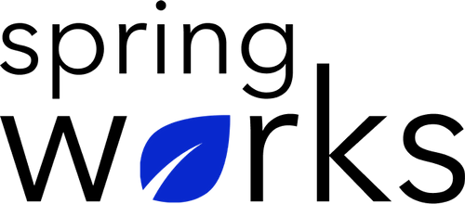
Free Template – Company Communication Survey

Use this survey to gain insight into the interaction and communication of employees.

Company communication is an essential part of growth and development of the organizations. Here is a survey to analyze how your employees feel about the form of communication you follow:

Communication (to be added as review instructions):

Your responses to this survey are anonymous. The leaders are committed to analyzing your results and taking action. Please answer this quick survey by <HOUR OF THE DAY> on <DATE>.

Thank you for your time. Your responses will help our organization become a better place to work. If you have any questions about the survey, please contact [insert name of contact person].

Demographic Information:

The following information is requested so that meaningful analysis and comparisons of group results can be made. Please check the circle corresponding to your answer.

Q: Your Gender:

- Male
- Female

Q: Your Department:

- Marketing
- Operations
- Tech
- Accounting
- HR

Q: Company Service:

- Under 1 Year
- 1-2 Year
- 3-5 Year
- 6-10 Year
- 10-15 Year
Company Communication Questionnaire

To answer clearly what you think or feel about each item, please follow these steps:

- Read each item fully before you start to mark your answer.
- Pick the one answer which most nearly says what you think or how you feel.
- While completing the questions, be sure to read the special instructions which are included.

Choose the most appropriate answer:

Q: My company keeps me fully informed about everything:

- Strongly agree
- Agree
- Neutral
- Disagree
- Strongly disagree

Q: When it comes to communication, my company is:

- Formal
- Semi-formal
- Informal
- Too informal

Q: My company encourages us to bond with other teammates:

- Strongly agree
- Agree
- Neutral
- Disagree
- Strongly disagree

Q: I feel I know about all the recent updates within the company:

- Strongly agree
- Agree
- Neutral
- Disagree
- Strongly disagree

Q: My manager listens to me and allows me to express my opinion:

- Yes
- Maybe
- Often
- No

Q: My company ensures that all my concerns are addressed:
- Yes
- Maybe
- Often
- No

Q: I can ask for help when I am confused about a particular task:

- Strongly agree
- Agree
- Neutral
- Disagree
- Strongly disagree

Q: Any particular area where you feel misinformed/not informed?

i.
ii.
iii.

